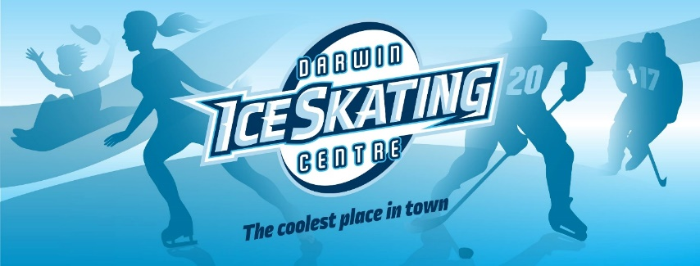

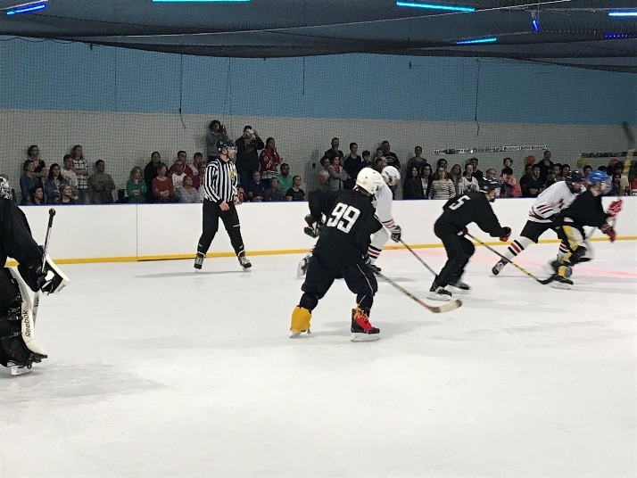 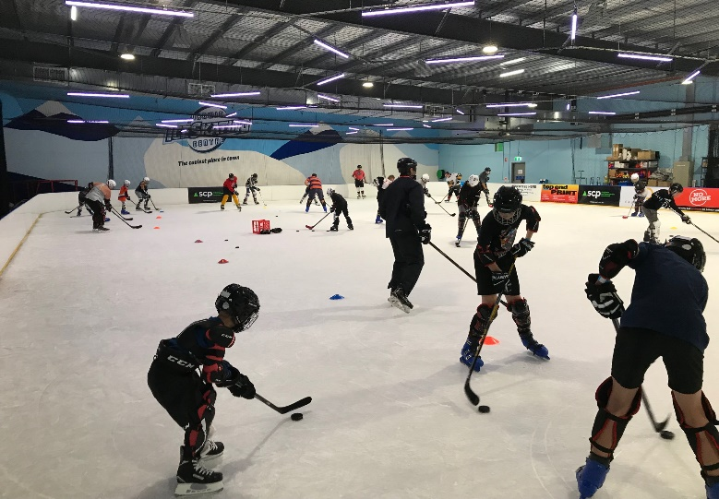

 

**LEARN2PLAY AND ADVANCED ICE HOCKEY PROGRAM**

* For beginners to current players
* Game is fun, fast, skilful and can be played all year round out of the sun and heat
* Lessons Saturday mornings
* 8am – 8:45am junior teams training (during school terms)
* 8:45am - 10:15am Intermediate training. For confident skaters and players who are ready to enhance their puck handling and shooting skills. You will need full protective equipment for this section, which includes ice hockey drills and scrimmage.

$30 per session.

* 10:20am - 11:20am Learn2Play for beginners and 11U team training. Focuses on getting comfortable with falling over and controlling a puck, and ice hockey skating skills such as forward skating, backward skating, crossovers, pivots, and stopping. $20 per session.
* Equipment available for hire if needed. $10
* Sports Vouchers accepted to go towards costs
* Experienced and highly skilled local coaches who have played overseas and interstate. Program is overseen by NSA Hockey, Australia’s premier ice hockey academy.

Where: Darwin Ice Skating Centre, 8 Osgood Drive, Eaton

Phone 0429 569 321 for more details. [www.darwiniceskating.com.au](http://www.darwiniceskating.com.au) File:Facebook logo (square).png Darwin Ice Skating